# Testing in the Context of a Software Development Lifecycle

## What is Testing in the Context of a Software Development Lifecycle (SDLC)

**# Source**: **Chatgpt (GPT-5-Standard) at [8/13/2025]**

**Testing in the Context of a Software Development Lifecycle (SDLC)** means integrating testing activities throughout the different phases of software development — not just at the end.

In modern approaches (like Agile or DevOps), testing is a **continuous process** that starts early (Shift-Left Testing) and continues after release (Shift-Right Testing).

## **How Testing Fits into Each SDLC Phase**

**# Source**: **Chatgpt (GPT-5-Standard) at [8/13/2025]**

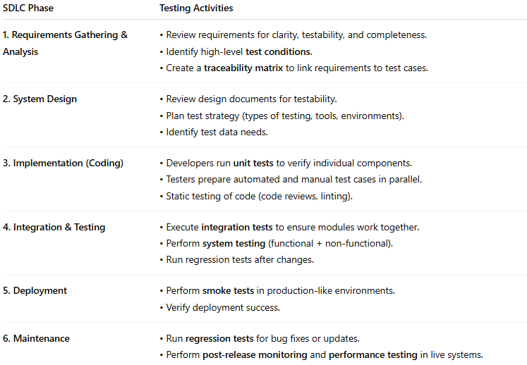

| **SDLC Phase** | **Testing Activities** |
| --- | --- |
| **1. Requirements Gathering & Analysis** | • Review requirements for clarity, testability, and completeness.• Identify high-level **test conditions**.• Create a **traceability matrix** to link requirements to test cases. |
| **2. System Design** | • Review design documents for testability.• Plan test strategy (types of testing, tools, environments).• Identify test data needs. |
| **3. Implementation (Coding)** | • Developers run **unit tests** to verify individual components.• Testers prepare automated and manual test cases in parallel.• Static testing of code (code reviews, linting). |
| **4. Integration & Testing** | • Execute **integration tests** to ensure modules work together.• Perform **system testing** (functional + non-functional).• Run regression tests after changes. |
| **5. Deployment** | • Perform **smoke tests** in production-like environments.• Verify deployment success. |
| **6. Maintenance** | • Run **regression tests** for bug fixes or updates.• Perform **post-release monitoring** and **performance testing** in live systems. |

## **Key Principles**

**# Source**: **Chatgpt (GPT-5-Standard) at [8/13/2025]**

* **Shift Left:** Start testing as early as possible in the SDLC to find defects sooner (cheaper to fix).
* **Continuous Testing:** Automated tests run frequently in CI/CD pipelines.
* **Test Basis Connection:** All tests trace back to requirements or design docs.
* **Feedback Loops:** Testing provides quick feedback to developers to improve quality.

## Visual Overview

**# Source**: **Chatgpt (GPT-5-Standard) at [8/13/2025]**

Here’s a simple flow of **SDLC with Testing**:

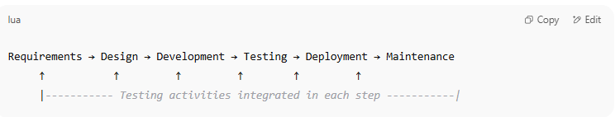

Requirements → Design → Development → Testing → Deployment → Maintenance

↑ ↑ ↑ ↑ ↑ ↑

|----------- Testing activities integrated in each step -----------|

## Testing in Each SDLC Model

**# Source**: **Chatgpt (GPT-5-Standard) at [8/13/2025]**

Alright — let’s break down **Testing in Each SDLC Model** so you can see how it’s handled depending on the development approach.

### 1. Waterfall Model

**# Source**: **Chatgpt (GPT-5-Standard) at [8/13/2025]**

* **Testing Phase:** Happens **after** development is complete.
* **Characteristics:**
  + Sequential; no overlap between phases.
  + Testing only starts when coding ends.
* **Pros:** Clear structure, easy to manage for small projects.
* **Cons:** Defects are found late; costly to fix.
* **Example:** Traditional government or manufacturing software projects.

### 2. V-Model (Verification & Validation Model)

**# Source**: **Chatgpt (GPT-5-Standard) at [8/13/2025]**

* **Testing Phase:** Testing activities are planned **parallel** to each development phase.
* **Characteristics:**
  + Left side = development stages (requirements → design → coding).
  + Right side = corresponding testing stages (unit → integration → system → acceptance testing).
* **Pros:** Testing starts early, better defect prevention.
* **Cons:** Less flexible for changing requirements.
* **Example:** Safety-critical software (medical devices, aerospace).

### 3. Iterative & Incremental Model

**# Source**: **Chatgpt (GPT-5-Standard) at [8/13/2025]**

* **Testing Phase:** Each iteration delivers part of the system and includes its own testing cycle.
* **Characteristics:**
  + Testing happens at the end of each iteration.
  + Continuous feedback to refine requirements.
* **Pros:** Early delivery of working parts, early defect detection.
* **Cons:** Requires strong planning for integration.
* **Example:** Banking systems, large enterprise apps.

### 4. Agile Model

**# Source**: **Chatgpt (GPT-5-Standard) at [8/13/2025]**

* **Testing Phase:** Testing is **continuous** within short sprints.
* **Characteristics:**
  + Testers work closely with developers.
  + Test automation is heavily used.
  + Frequent regression testing.
* **Pros:** Fast feedback, adaptable to changes.
* **Cons:** Requires high collaboration and skilled team members.
* **Example:** Web apps, startups, SaaS products.

### 5. Spiral Model

**# Source**: **Chatgpt (GPT-5-Standard) at [8/13/2025]**

* **Testing Phase:** Testing occurs in **each cycle** (prototype → build → refine).
* **Characteristics:**
  + Combines iterative development with risk analysis.
  + Early prototypes tested before full implementation.
* **Pros:** Great for managing high-risk projects.
* **Cons:** Can be costly and complex.
* **Example:** R&D software, defense projects.

### 6. Big Bang Model

**# Source**: **Chatgpt (GPT-5-Standard) at [8/13/2025]**

* **Testing Phase:** Testing happens **after coding everything** — no intermediate testing.
* **Characteristics:**
  + No formal process, just build and test at the end.
* **Pros:** Simple for very small projects.
* **Cons:** Extremely risky, late defect discovery.
* **Example:** Proof-of-concept projects.

## SDLC and good testing practices

**# Source**: **Chatgpt (GPT-5-Standard) at [8/13/2025]**

Here’s a clear overview of **SDLC** combined with **good testing practices** so you can see how they fit together.

### 1. SDLC Phases with Testing Focus

**# Source**: **Chatgpt (GPT-5-Standard) at [8/13/2025]**

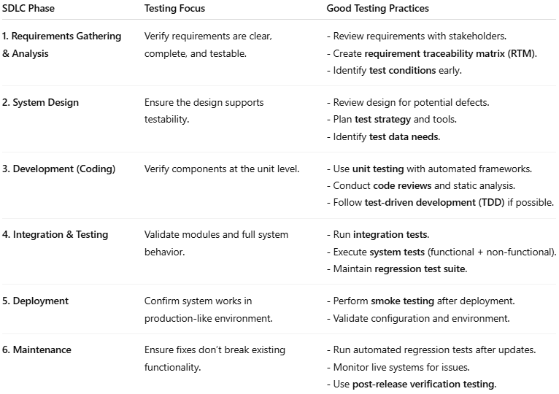

| **SDLC Phase** | **Testing Focus** | **Good Testing Practices** |
| --- | --- | --- |
| **1. Requirements Gathering & Analysis** | Verify requirements are clear, complete, and testable. | - Review requirements with stakeholders.- Create **requirement traceability matrix (RTM)**.- Identify **test conditions** early. |
| **2. System Design** | Ensure the design supports testability. | - Review design for potential defects.- Plan **test strategy** and tools.- Identify **test data needs**. |
| **3. Development (Coding)** | Verify components at the unit level. | - Use **unit testing** with automated frameworks.- Conduct **code reviews** and static analysis.- Follow **test-driven development (TDD)** if possible. |
| **4. Integration & Testing** | Validate modules and full system behavior. | - Run **integration tests**.- Execute **system tests** (functional + non-functional).- Maintain **regression test suite**. |
| **5. Deployment** | Confirm system works in production-like environment. | - Perform **smoke testing** after deployment.- Validate configuration and environment. |
| **6. Maintenance** | Ensure fixes don’t break existing functionality. | - Run automated regression tests after updates.- Monitor live systems for issues.- Use **post-release verification testing**. |

### 2. Good Testing Practices Across the SDLC

**# Source**: **Chatgpt (GPT-5-Standard) at [8/13/2025]**

These apply no matter the model (Waterfall, Agile, V-Model, etc.):

1. **Shift-Left Testing**
   * Start testing activities early in the SDLC to catch defects sooner.
2. **Traceability**
   * Link every test case to a requirement (RTM) so nothing is missed.
3. **Test Automation Where Suitable**
   * Automate repetitive, stable test cases (unit, regression, smoke tests).
4. **Continuous Testing in CI/CD**
   * Integrate automated tests into the build pipeline.
5. **Test Data Management**
   * Use realistic, valid, and anonymized test data.
6. **Regular Regression Testing**
   * Ensure changes don’t break previously working features.
7. **Balanced Testing Levels**
   * Use a **Test Pyramid** approach: more unit tests, fewer UI tests.
8. **Static Testing**
   * Review and inspect requirements, designs, and code before execution testing.
9. **Risk-Based Testing**
   * Prioritize testing of high-impact, high-probability failure areas.
10. **Clear Test Documentation**
    * Maintain up-to-date test plans, cases, and reports.